Report For Final Project

1. Introduction

The purpose of doing Hyperparameter Database is giving some recommendations for researchers who are doing machine learning projects. Researchers could have a roughly idea to select models before actually running models by searching the database.

1. Selecting features

In this database schema, we did not store every hyperparameters for each machine learning algorithms, because we find out that some of the parameters remained their default values to the end of the learning process. Thus, we decide to store the parameters whose actual values differ from default values, and we got such database schema.

1. Usecase in database

Heyuan Zhang’s Part:

Two functions: in the first one, we can find the best model for certain data set. In the second one, we could find best GBM model base on the running time and data set.

Views:

Queries:

YINAN SUN’s Part:

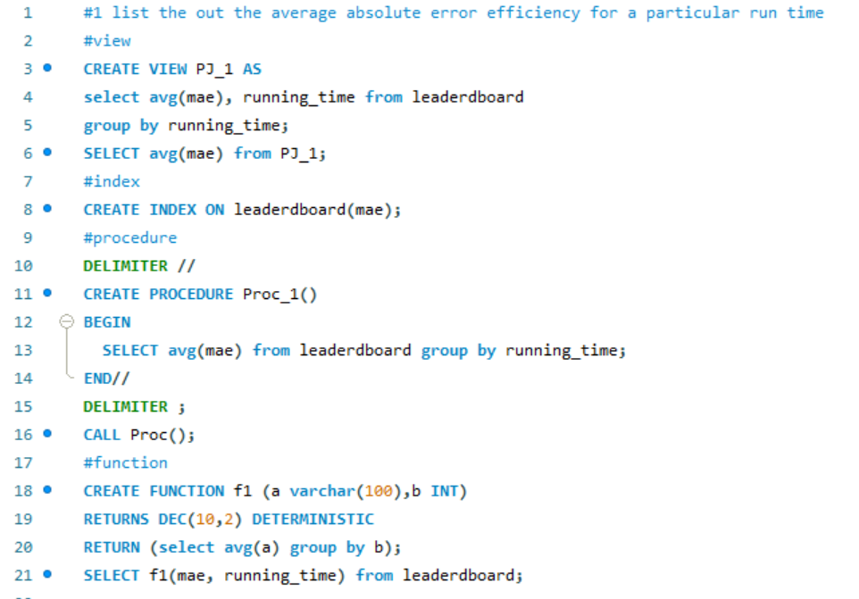

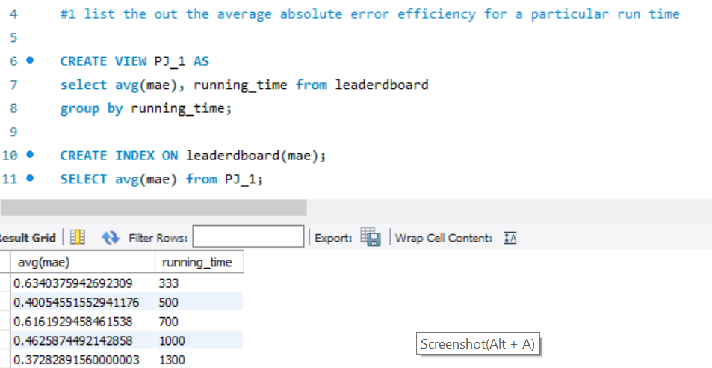

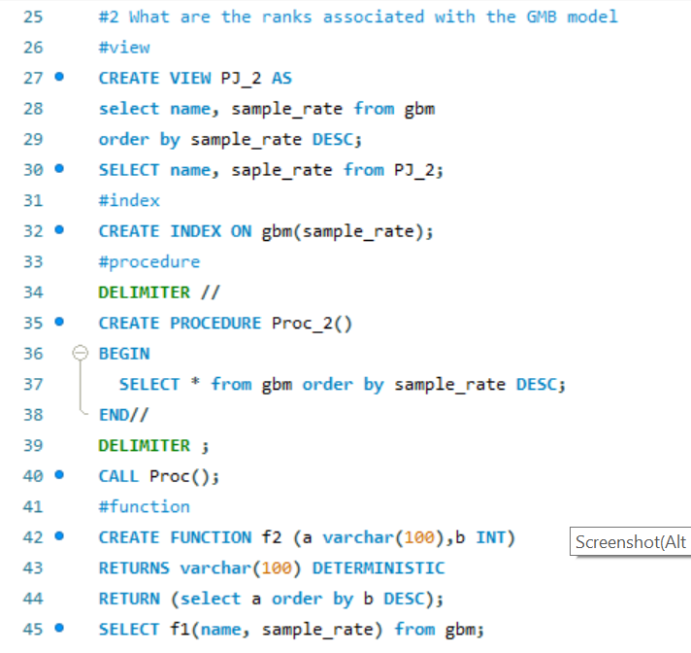

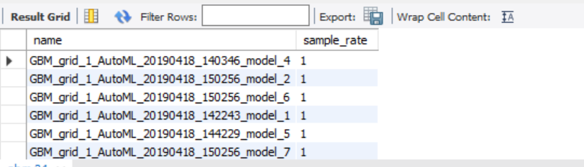

Use Case 3

How many GBM models were generated for a particular run

